Australia New Zealand Trauma Registry

Data Use Policy (DUP)

Revised November 2021

Contents

TERMS OF USE 2
Purpose 3
The ATR Database 3
Access Guidelines 3
Accessing ATR Data – Flow Chart 5
Secure e-Research Platform (SeRP) Overview 6
Acknowledgements and Authorship 6
Researcher Declaration 7

TERMS OF USE

The Australian Trauma Quality Improvement Program (AusTQIP) Steering Committee established the ATR to be a repository of trauma related data voluntarily reported by contributing trauma centers. The ATR is governed by the ATR Board and AusTQIP Steering Committee.

Specific Terms of Agreement: Limited license is granted to use said information from the ATR, as per the Agreement’s Access Guidelines, provided the Requester agrees to the following provisions:

- Treat the information received from the ATR as non-public health data. The data may never be used by Requester as a basis for legal, administrative or other actions that can directly affect an individual whose medical or personal information is included in a case in the data.
- Use the information received under the provisions of this Agreement only for the following not-for-profit purposes: research, advocacy, medical education, patient education, or other trauma care-related activities supported by not-for-profit organisations.
- All Information derived from the ATR shall remain the full and copyrighted property of the ATR and shall be so noted in educational material, website presentations, and publications (as per the Acknowledgments and Authorship requirements).
- Warrant that the AusTQIP Steering Committee, ATR Board and ATR employees and agents are not responsible for any claims arising from works based on the original data, text, tables, or figures.
- Indemnify the AusTQIP Steering Committee, ATR Board and ATR employees and agents from any and all liability, loss, or damage suffered as a result of claims, demands, costs, or judgments arising out of use of ATR information.
- Requestor may not sublease or permit other parties to use ATR data

The Requester's obligations hereunder shall remain in full force and effect and survive the completion of the Requester's defined project described herein above. The terms of this Agreement shall be binding upon the Requester and the organisation through which the project is conducted.

Data Use Policy (DUP)

Purpose
The collection of trauma data is fundamental for trauma quality improvement and research. An objective of the ATR Board is to encourage and ensure the ethical and appropriate use of ATR data for research. This policy outlines the processes for accessing, analysing, reporting and acknowledging ATR data in order to ensure the guidelines of the AusTQIP Collaboration Agreement and Memorandum of Understanding (New Zealand Trauma Registry collaboration) are adhered to.

The ATR Database
The ATR collects deidentified trauma data from Australian and New Zealand trauma centres, submitted directly or via centralised registries, in accordance with the binational data dictionary. The ATR has consecutive, high quality, in-hospital data for researchers to access from 1 July 2015 for Australian data and 1 July 2017 for New Zealand data. The ATR website has details of all contributing sites/registries: https://atr.org.au/partners as well as the data dictionary https://atr.org.au/data-set.

The ATR database is stored within a secure system by the data host organisation, Monash University. Researchers can only access data via the ATR Portal (for sites that contribute data to the ATR) or the secure online research platform (SeRP) for non-contributing sites/organisations. Access to ATR data is subject to the Access Guidelines and the Accessing ATR Data flowchart, outlined on pages 3-5.

Access Guidelines
- Researchers from contributing sites – all contributing sites will have access to their own aggregate data for comparison with other sites via the ATR Portal. The Site Investigator/s will have password protected access. If a contributing site requests its own performance data outside what is available on the ATR Portal, this will be provided without ATR Board approval. All requests for this level of data should be made in writing to the ATR Manager, with accompanying authorisation from the site Principal Investigator in accordance with site governance. The ATR Board and AusTQIP Steering Committee will be given a record of such requests on a quarterly basis. Appropriate acknowledgements must be made prior to publication/presentation (see Acknowledgements and Authorship, page 6, for details.
- Researchers from non-contributing sites/organisations – all data requests require completion and submission of the Data Request Form and signed Data Use Policy to the ATR Manager and approval by the ATR Board.
- Researchers may request the ATR to undertake analyses or provide summary data.
- Access to New Zealand data will require additional written approval from the Data Governance Group of the NZ Trauma Registry. This request will be made by the ATR Manager once the data request has been reviewed and approved by the ATR Board.
- Deidentified patient level or aggregate data, once approved, will only be accessible by approved researchers via the secure e-research platform (SeRP) for review and analysis – see SeRP Overview page 6.
- Any output data for publication must be reviewed by the ATR Board prior to publication to ensure adherence to all agreements and policies, including section 8 of the AusTQIP Collaboration Agreement and section 9 of the New Zealand MoU.
- Aggregate data identifiable at the site or jurisdiction level is governed by the ATR Outlier Policy.
- Data will be withheld if there is a possibility of harm to an individual or community resulting from the use of ATR data, e.g. risk of patient identification.
- Data must not be used for any reason beyond that approved, and no release to a third party is permitted (see Terms of Use, page 2).
- Researchers must be fully informed of the legal requirements for data use that are pursuant to the data being requested as per the AusTQIP Collaboration Agreement and the New Zealand MoU.
- Researchers accept full responsibility for the consequences of inappropriate or harmful use of ATR data.
- Studies using ATR data require appropriate acknowledgements (see Acknowledgements and Authorship, page 6).
- Only data requests by contributing sites will be provided free of charge. The provision of data for all other data requests may be subject to a fee-for-service for non-contributing sites. Refer to the Fees Policy for details.

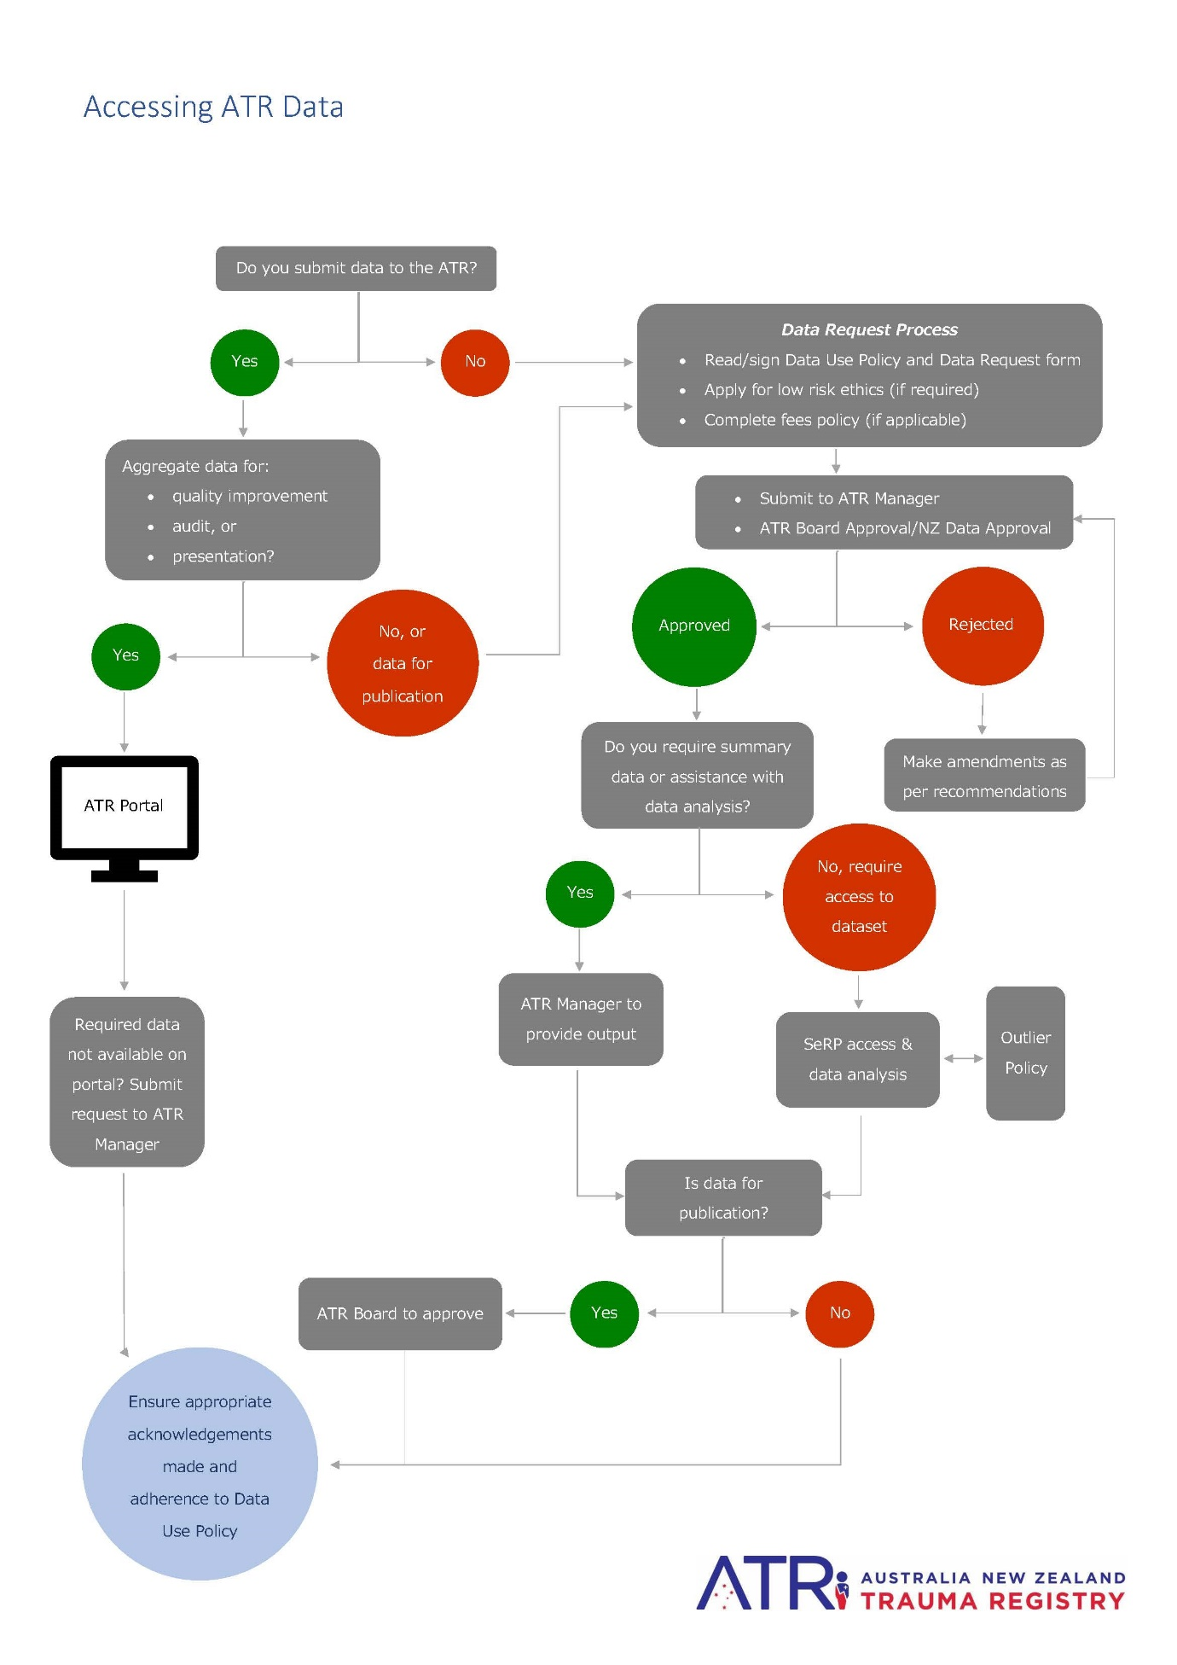
Accessing ATR Data – Flow Chart

Secure e-Research Platform (SeRP) Overview
SeRP is a safe and secure e-research platform that allows data owners and researchers to store, access, share, link and analyse data at scale, in a fully governed highly secure environment, whilst maintaining full control of the data at all times. SeRP features the ability to access data via secure remote access. This is the platform with which datasets will be accessed by researchers.
The ATR Data Manager, as SeRP data custodian, will have access to the SeRP, as will the Data Host Director and any pre-authorised researchers. Approved researchers who have an existing Monash University authcate account will use their username and password to access SeRP. Affiliate appointments will be provided for external researchers and details of access will be provided once the project has been approved and data is ready for access. Researchers can only perform analyses while in the SeRP and requests to export aggregate output must be submitted in SeRP to the ATR Manager.

Acknowledgements and Authorship
- ATR Data provided to researchers is on the condition that the ATR is acknowledged as the source of the data. The suggested citation is:
The Australia New Zealand Trauma Registry (ATR) is a collaborative project that collects data from Australian and New Zealand trauma centres. The data in this publication is available with the cooperation of all the collaborating sites, and by review from the ATR Board. Strict guidelines have been applied to its use. The authors extend thanks to all collaborators for the provision of the data.
- If the acknowledgments refer to any AusTQIP Collaborators specifically, written permission to be acknowledged must be provided (section 11.f of the Collaboration Framework).
- The ATR data completeness applicable to the period/s of ATR data provided must be quoted with any published data.
- The ATR Manager requires a copy of any publication, document or presentation that uses ATR data for reporting and compliance purposes. The ATR maintains a log of all requests for data and its subsequent use to monitor its contribution to trauma research and quality improvement.

Researcher Declaration

I declare I have read and fully understood the contents of the Data Use Policy (DUP). I have completed the Data Request Form in line with the DUP and submitted both to the ATR Manager as per both documents’ requirements.

Principal researcher (please print name): ……………………………………………………………………….

Signature: …………………………………………………. Date: …………………………………….

